

HUMAN BIOLOGICAL SCIENCE

STAGE 3 SAMPLE EXAMINATION

Section 7 of the New WACE Manual: General Information 2006–2009 outlines the policy on WACE examinations.

Further information about the WACE Examinations policy can be accessed from the Curriculum Council website at http://newwace.curriculum.wa.edu.au/pages/about_wace_manual.asp.

The purpose for providing a sample examination is to provide teachers with an example of how the course will be examined. Further finetuning will be made to this sample in 2008 by the examination panel following consultation with teachers, measurement specialists and advice from the Assessment, Review and Moderation (ARM) panel.

0000.doc



Western Australian Certificate of Education, Sample External Examination

Question/Answer Booklet

HUMAN BIOLOGICAL SCIENCE
Please place your student identification label in this box
WRITTEN PAPER
STAGE 3

Student Number: In figures

In words

Time allowed for this paper
Reading time before commencing work: 10 minutes
Working time for paper: Three hours

Materials required/recommended for this paper

To be provided by the supervisor
This question/Answer Booklet

To be provided by the candidate
Standard items: Pens, pencils, eraser or correction fluid, ruler, highlighter

Important note to candidates
No other items may be taken into the examination room. It is your responsibility to ensure that you do not have any unauthorised notes or other items of a non-personal nature in the examination room. If you have any unauthorised material with you, hand it to the supervisor before reading any further.

Structure of this paper

Section |  | Suggested working time (minutes) | No. of questions available | No. of questions to be attempted | Marks available
1 | Multiple Choice | 30 | 20 | ALL | 40
2 | Short Answer Questions | 100 | 11 | ALL | 100
3 | Extended Answer Questions | 50 | 4 | 2 | 30  30
 |  |  |  | Total marks | 200

Instructions to candidates

- Please ensure you attach your student identification label in the box on page 1, as well as write your student number in the spaces provided.

- The rules for the conduct of Curriculum Council examinations are detailed in the Student Information Handbook. Sitting this examination implies that you agree to abide by these rules.

Section One Answer all questions, using a 2B, B or HB pencil, on a separate Multiple Choice Answer Sheet. DO not use a ball point or ink pen.

Section Two Answer in the spaces provided in this Question/Answer Booklet. DO not answer this section in the section in the Standard Answer Book. A blue or black ball point or ink pen should be used.

Section Three Write your answers in the Standard Answer Book. Your writing or printing must be LEGIBLE. Use a blue or black ball point pen (not pencil) for this section.

- Answers may be presented in a combination of different ways provided they communicate your ideas effectively. You may choose to :
  - Present a clearly labelled diagram
  - Write notes besides a clear diagram
  - Write lists of points, with sentences that link them
  - Write concisely worded sentences
  - Use some other appropriate way to present ideas

- At the end of the examination your Question/Answer Booklet should be attached to the front of the Standard Answer Book/s with the paper binder provided.

SECTION ONE: MULTIPLE CHOICE [40 marks]
Mark your answers to Questions 1-20 on the SEPARATE MULTIPLE CHOICE ANSWER SHEET, using a 2B, B or HB pencil.

SELECT THE CORRECT ALTERNATIVE IN EACH OF THE FOLLOWING QUESTIONS.

Question 1
Neurons are said to be sensitive and conductive. This means that they can:
  - secrete neurotransmitters
  - be stimulated to transmit nervous impulses
  - stimulate a muscle to contract
  - only be stimulated by electric currents.

Question 2
You are driving down the road at night and suddenly you see the lights of a car coming straight towards you on the wrong side of the road. What part of the nervous system is stimulated?

  - the parasympathetic division of the central nervous system
  - the sympathetic division of the somatic nervous system
  - the parasympathetic division of the autonomic nervous system
  - the sympathetic division of the autonomic nervous system.

Question 3
Which of the following will help to restore a person who has been immersed in icy water to normal body temperature?

- increased sweating
(b) capillary vasoconstriction in the skin
(c) decreased metabolism
(d) capillary vasodilation in the skin.

Question 4
When blood sugar levels decrease, a hormone is secreted from an endocrine gland and blood sugar level returns to normal. With reference to this statement and the homeostatic model:
stimulus, receptor, control centre, effector, response
Which of the following is the CORRECT sequence?

  - low blood sugar, pancreas, pancreas releases insulin, liver, glycogenolysis
(b) low blood sugar, hypothalamus, pancreas releases glucagon, liver, glycogenesis
(c) low blood sugar, pancreas, pancreas releases glucagon, liver, low blood sugar, hypothalamus, hypothalamus releases A.C.T.H., liver, blood levels return to normal.
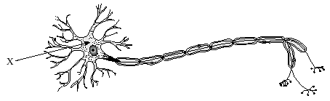
The diagram shows a nerve cell.

[From: Abbotsford Collegiate, n.d.]

Question 5
Nerves cells like the one shown in the diagram would be found in:

(a) touch receptors in the skin
(b) the white matter of the spinal cord
(c) the grey matter of the spinal cord
(d) the retina of the eye

Question 6
Which of the following is the neurotransmitter at the neuro-muscular junction (end plate)?

- Acetylcholine
- Norepinephrine
- Epinephrine
- Dopamine

Question 7
The half-life of carbon-14 is 5730 years. When an organism dies the time taken for 75% of its carbon-14 to disappear:

  - is11 460 years
  - is 8595 years
  - is 4297.5 years
  - depends on the initial quantity of carbon-14 present

Question 8
Which of the following trends in physical appearance has occurred for during the evolution of the genus Homo?

- enlarged teeth
- flatter face
(c) sloping forehead
(d) S shaped vertebral column

In questions 9 and 10 refer to the diagram below which shows the location of certain endocrine glands in the human body.

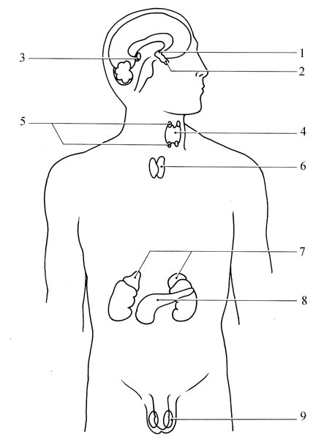
C

D

E

F

G

H

A

B
[Adapted from: University of Portsmouth, n.d.]

Question 9
In the table below, which row shows the correct names of the glands B, C, D and F?

 | B | C | D | F
(a) | Pineal Hypothalamus | Thymus | Pancreas | Testes
(b) | Pituitary | Thymus | Adrenal | Ovary
(c) | Parathyroid | Hypothalamus | Thyroid | Adrenal
(d) | Pituitary | Parathyroid | Kidney | Adrenal

Question 10
In the table below, which row shows the correct name of a hormone secreted by the glands B, D, G, and F?

 | B | D | G | F
(a) | Thyroxine | Antidiuretic Hormone | Adrenalin | Follicle Stimulating Hormone
(b) | Follicle Stimulating Hormone | Thyroxine | Pancreatic  Amylase | Adrenalin
(c) | Follicle Stimulating Hormone | Adrenalin | Glucagon | Oestrogen
(d) | Oestrogen | Adrenalin | Glycogen | Follicle Stimulating Hormone

Question 11
Organ transplant patients are given drugs to minimise the rejection of transplanted organs.
These drugs work by:

(a) inhibiting the production of enzymes by the transplanted organ that lead to rejection
(b) suppressing the immune response that recognises ‘foreign’ molecules on the transplanted organs
(c) acting as antibiotics so that bacteria are killed before causing infections in transplanted organs
(d) promoting the repair of the blood vessel connections between the transplanted organ and the host body.

Question 12
A mother with blood group O has a child by a man with whose blood group is A. The child:

  - could only be blood group O as this is the most common blood group
(b) could be blood group B if the mother was (I^{B}i^{O} )
- could not be blood group AB or B
- could only be blood group A, as blood group A is dominant over blood group O.

Question 13
An effector organ for a homeostasis (feedback) loop that regulates body temperature might be the:

  - brain
  - sweat glands
  - neurons
  - temperature sensors.

Question 14
Which experimental design would give results that were the most reliable?

(a) one that was repeated by 2 labs with two trials, each sample size: 510,000
(b) a single trial, with total sample size: 10,000
(c) one that was repeated by 2 labs with two trials, each sample size: 1,000
(d) a single trial, with total sample size: 1,000.

Question 15
What chemical in the plasma (cell) membrane forms channels and carriers?

- cholesterol
- carbohydrate
- nucleic acid
- protein.

Question 16
The part of the brain associated with thought and reasoning is the:

(a) cerebellum
(b) medulla oblongata
(c) cerebrum
(d) hypothalamus.

Question 17
The types of joints affected by a person whose left shoulder and neck was damaged in a car accident would be:

(a) synovial, gliding and fibrous
(b) gliding, pivot, synovial and cartilaginous
(c) fibrous, cartilaginous and pivot
(d) synovial and pivot only.

Question 18
People living in small island communities for a number of generations without significant immigration sometimes exhibit unusual levels of genetic diseases due to recessive mutations. This is due to:

(a) founder effects from the original first settlers
(b) a diet lacking in essential antioxidants
(c) high levels of radiation causing mutations
(d) elevated levels of genetic mutations accumulating in the population.

Question 19
If siblings in a family show marked inherent variations in skin colour it would be because:

(a) they differ in the amount of time they spend in the sun
(b) these factors are determined polygenically
(c) dark colouration is a dominant trait
(d) skin colour is related to blood group.

Question 20
A child receiving antibodies from its mother's breast milk develops:

(a) naturally acquired passive immunity
(b) artificially acquired active immunity
(c) artificially acquired passive immunity
(d) naturally acquired active immunity.

END OF SECTION ONE

SECTION TWO: SHORT ANSWER [100 marks]
Answer ALL questions in Section 2. Answer in the spaces provided.
____________________________________________________________________

Question 21 [16 marks]

A scientist was investigating the effectiveness of a newly developed drug, Neurogen and its ability to improve recovery from nerve cell injury. The experiment was performed as described.

Nerve cells were placed into culture medium (a solution containing nutrients to keep the cells alive and help them grow). An equal number of nerve cells (in culture medium) were transferred into thirty test tubes and maintained under constant temperature and oxygen levels. Ten of the test tubes received no treatment, ten tubes received a large, single dose of Neurogen and the remaining ten tubes had a series of smaller doses of Neurogen added each week until week 8. The total amount used in the series of small doses was the same as the single large dose. The treatment started at the end of week 2 of the investigation.

At the end of each week one test tube was selected from each treatment and the growth of nerve axons in the test tubes was measured. The results are shown in the table below.

Table 1: Growth of nerve axons with different treatments

Time  (weeks) | Treatment A  No treatment | Treatment B  Single large dose  of Neurogen | Treatment C  Series of small doses of Neurogen
0 | 0.01 | 0.02 | 0.01
1 | 0.04 | 0.06 | 0.05
2 | 0.05 | 0.07 | 0.08
3 | 0.10 | 0.15 | 0.21
4 | 0.12 | 0.30 | 0.35
5 | 0.15 | 0.45 | 0.50
6 | 0.16 | 0.55 | 0.65
7 | 0.18 | 0.56 | 0.80
8 | 0.19 | 0.58 | 1.00
9 | 0.20 | 0.58 | 1.15
10 | 0.21 | 0.59 | 1.20

(a) Draw an appropriate graph to represent the results in Table 1. [5 marks]

(b) State a possible conclusion from this experiment. [1mark]

(c) Discuss two (2) possible sources of error in this experiment and make suggestions on how the reliability of the results could be improved. [4 marks]

(d) Explain why measurements were taken for two weeks before treatments were given.
[2 marks]

(e) The last dose for treatment C was given at the beginning of week 8. What would be expected to happen to axon growth over the next few weeks? Explain the reasons for your answer. [4 marks]

Question 22 [14 marks]

Human blood-calcium concentrations are under homeostatic control. When the concentration of calcium in the blood begins to fall the parathyroid gland releases parathyroid hormone. This hormone stimulates bone cells called osteoclasts to break down bone and release calcium into the blood.
When the concentration of calcium rises in the blood, specialised cells associated with the thyroid gland release the hormone calcitonin. Calcitonin acts on bone and increases the amount of calcium that is deposited into bone.

- Use the information given above to complete the flowchart by filling in the six empty boxes. (8 marks)

Figure 22: Control of blood calcium

blood calcium concentration 2.2 to 2.5 mmolL⁻¹
increase in concentration of blood calcium
decrease in concentration of blood calcium

release release

acts on acts on

causing results in

blood calcium concentration 2.2 to 2.5 mmolL⁻¹
increase in concentration of blood calcium
decrease in concentration of blood calcium

(b) Research findings have indicated that low oestrogen levels are directly linked to Osteoporosis (the loss of calcium and other minerals from the bone), causing a decrease in bone mass. This makes the bones brittle and easy to fracture.

Explain how low oestrogen levels would affect the secretion of calcitonin and parathyroid hormone.
[2 marks]

(c) Describe how daily calcium supplements could help older women reduce the risk of osteoporosis in terms of the flow chart.
[2 marks]

(d) Vitamin A is used to treat some skin conditions and many women use Vitamin A
preparations to promote "younger looking skin". One of the hazards of using
Vitamin A is that it stimulates the actions of osteoclasts.

Refer to the flow chart and explain how this would affect the blood calcium level.
[2 marks]

Question 23 [7 marks]
[Adapted from: Victorian Curriculum and Assessment Authority, 2004]

Several hormones are involved in maintaining homeostasis in humans. The Antidiuretic hormone is important in controlling water balance. The following graph shows changes in the concentration of this hormone as plasma solute concentration increases.

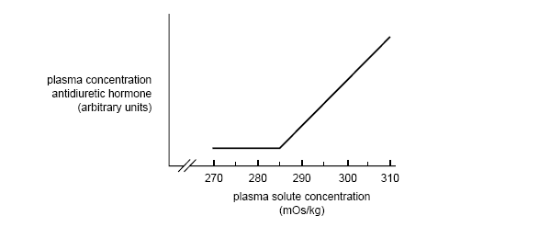

http://www.vcaa.vic.edu.au/vce/studies/biology/pastexams/biology12002.pdf

(a) At what plasma solute concentration is the release of antidiuretic hormone triggered?
[1 mark]

(b) Antidiretic hormone is released from a gland. Name the gland and its specific release site. [2 marks]

(c) Explain the action of antidiuretic hormone in controlling water balance. [4 marks]

Question 24 [8 marks]

Refer to the following flowchart showing protein synthesis:
Information
In
DNA
Process 1
Process 2
Polypeptide with correct amino
acid sequence

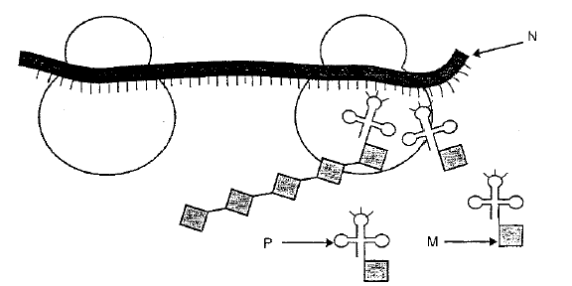

(a) Which process does the above diagram represent? (Process 1 or 2)
Name the process. [2 marks]

- Structures P and N in the above diagram are different forms of the same molecule. Identify and name these two structures. [2 marks]

- Describe the functions of P and N in the process named in (a) [4 marks]

Question 25 [6 marks]

The diagram below represents the structural components of a myofibril, which are found in skeletal muscle fibres. Diagram A is showing the myofibril when the muscle is at rest.
Diagram B is showing the myofibril is contracted. Refer to the diagrams when answering the questions below:

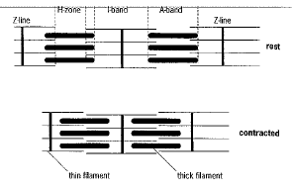
A
B
[From: Boyle & Senior, 2002]

- In old age, the myofibrils lose some of the cross connections between the thick and thin filaments. How would this affect the functioning of the whole muscle?
[2 marks]

(b) Describe the changes that occur in the myofibrils when muscle contraction takes place. Refer to the above diagrams in your answer. [4 marks]

Question 26 [7 marks]

In a remarkable experiment conducted in 1775, two men walked into an open brick oven in which the air was dry and had been heated to 127°C. After 20 minutes they emerged unharmed.

- Where are the body's thermoreceptors located? [1 mark]

(b) What two responses to the high temperatures would occur in the skin of the men in the oven? [2 marks]

(c) The men's breathing rates increased during the time in the oven. Give one reason why this would happen. [2 marks]

(d) How would dry air have helped the men's survival? [2 marks]

Question 27 [6 marks]
Use the inheritance of ABO blood group to explain each of the following:

(a) Co-dominance [2 marks]

(b) Recessiveness [2 marks]

(c) Autosomal inheritance [2 marks]

Question 28 [6 marks]

(a) Populations in different geographical areas appear to have a common hair and skin colour. For example, Asians have predominantly black hair and dark skin. Scandinavians have mainly blonde hair and fair skin. Using your understanding of evolutionary mechanisms, explain one way such differences may have arisen in different populations. [2 marks]

(b) In the 1930s, a scientific research team, following in the footsteps of early European explorers, arrived at an isolated island in the middle of the Pacific Ocean. It was the southern-most island of a wide spread chain of islands. Most of the population on this island were Melanesian but had blonde hair. This surprised the researchers, as similar populations on the other islands in the chain had the characteristic dark hair common to most Melanesians.

Describe TWO possible genetic mechanisms that could account for the hair colour of the population on the isolated island being different from other Melanesian populations. [4 marks]

Question 29 [12 marks]

Biotechnology now plays an important role in the production of synthetic hormones. Recombinant DNA technology provides the technique currently used to manufacture hormones like human Insulin.

bacteria
A
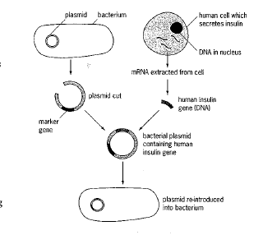

B
*C
*cuts this structure
D
The diagram (left) represents the process of recombinant DNA technology used to produce human insulin.

[Adapted from: Boyle & Senior, 2002]

- Name structures A, B, C and D in the table below and state each structures role in the production of Insulin. [8 marks]

 | NAME OF STRUCTURE | ROLE IN RECOMBINANT DNA PROCESS
A

B

C

D

(b) What risks and benefits are associated with recombinant DNA technology for a patient requiring Insulin? [4 marks]

Question 30 [8 marks]

The following questions refer to a reflex arc.

(a) When the skin is stimulated, such as when burnt by a hot object, people react before they are consciously aware of the pain. Explain why you are unable to consciously control a reflex action. [2 marks]

(b) Explain why the nerve impulse can travel in only one direction in a reflex arc.
[2 marks]

(c) Some nerve cell axons have a myelin sheath. In what ways does the myelin sheath affect the functioning of the cell? [2 marks]
[Adapted from: Victorian Curriculum and Assessment Authority, 2003]

(d) How can ageing affect the myelin sheath and the functioning of the nervous system?
[2 marks]

Question 31 [10 marks]

Figure 20: Normal knee joint

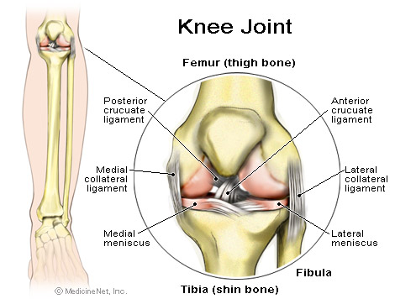

Hyaline Cartilage

Cruciate Ligament

[From: MedicineNet Inc., n.d.]

(a) Describe how the structure of the knee joint allows flexion and extension but not rotation. [2 marks]

(b) Explain how the tissues forming the following structures are suited to their function in the joint.

Tibia: [2 marks]

Cruciate ligament: [2 marks]

(c) Osteoarthritis is the most common joint disorder and by the age of about 70 years affects most people to some degree. Osteoarthritis can begin with abnormal cells in the cartilage that produce collagen. This causes the cartilage to crack forming tiny cavities in the bone beneath the cartilage.

Explain two different possible types of technologies that can be used to treat osteoarthritis. [4 marks]

END OF SECTION TWO
SECTION THREE: EXTENDED RESPONSE [60 marks]

Answer Question 32 and ONE other question from Question 33, 34 or 35.

Each question is worth 30 marks.

Answers can be in the form of:
- a flow chart
- well annotated diagrams
- tables
- a well described list of dot points.

Question 32 (Compulsory) [30 marks]

A researcher working for a pharmaceutical company had developed an anti-inflammatory related compound (‘Drug X’) which showed promise in the treatment of Arthritis. Anti-inflammatory compounds reduce swelling and make movement at arthritic joints easier and less painful. Tests on mice indicated that the compound was far more powerful than other similarly acting arthritis drugs that are presently on the market.

The pharmaceutical company already has another Arthritis drug, "Arthramat" on the market. The effectiveness of Arthramat is limited if not taken at the first signs of immobility and pain in the joints.

(a) Using the above information design an investigation to compare the effectiveness of ‘Drug X’ and Arthromat

Ensure you consider the following:
- variables
- hypothesis
- pre-testing
- methodology to allow ethical and safe data collection
- measures to achieve reliability and to reduce errors.

The compound was developed from an anti-inflammatory compound found in a flatworm that inhabits the coral reefs in northern Australia. Researchers identified the gene coding for the active protein in the compound. Using biotechnological techniques, a culture of bacteria was developed that produced the protein. The protein was purified and used in the drug tested on arthritic mice.

(b) Outline some possible risks, ethical issues, and benefits of using this new drug in the treatment of arthritis in humans.

Choose ONE question only from Questions 33, 34 or 35.

Question 33 [30 marks]
The skulls below show the evolutionary sequence of hominin skulls from the oldest, A. afarensis to the current, H. sapiens.

Figure 20 Hominin skulls

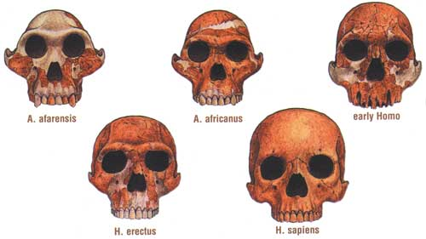

(Hennings, 1999)

(a) Identify five evolutionary physical changes that are evident from the diagram when the skulls are compared. Suggest ONE reason for each change. [10 marks]

(b) Describe 4 cultural evolutionary changes that resulted from the development of the hominins represented above. [8 marks]

(c) List and describe 2 techniques that scientists would have used to assist them in differentiating and classifying these fossil skulls [12 marks]

OR

Question 34 [30 marks]
Ageing in humans is associated with changing functions of the musculo-skeletal and nervous systems.

(a) Outline medical technologies used in the treatment of the changing functions caused by ageing in either the: [20 marks]
i musculo-skeletal system
(refer to treatments of osteoporosis and osteoarthritis)
OR
ii nervous system
(refer to Parkinson's disease and Alzheimer’s disease)

(b) Select one medical technology outlined to state ethical issues, risks, and benefits to the patient. [10 marks]

OR

Question 35 [30 marks]
Through recent advancements in human biology, specific resistance mechanisms of the body can be stimulated by the use of vaccines that are produced artificially. Also enhancing the body's defence are artificially produced (monoclonal) antibodies that can provide treatment for infections and cancer and for the prevention of tissue rejection after transplantation.

- Vaccines promote two different types of immunity—passive and active.
Explain the differences in the body’s response to the two different types of immunity.
[10 marks]

- Outline the processes involved in the production of monoclonal antibodies [10 marks]

- What are the risks and benefits of using monoclonal antibodies for individuals and populations?
[10 marks]

Circle the ONE question you have chosen to answer: Question 33 / 34 / 35

END OF PAPER
ACKNOWLEDGEMENTS

SECTION ONE

Question 5: Diagram from: Abbotsford Collegiate. (n.d.).Biology 11 and Biology 12. Retrieved September, 2007, from http://www.abbysenior.com/biology/nervous_system.htm.

Questions 9 & 10: Diagram adapted from: University of Portsmouth. (n.d.). Endocrine system: Key diagram : Male. Retrieved September, 2007, from http://www.sci.port.ac.uk/rad/anatomy/012/001.htm.

SECTION TWO

Question 23: Adapted from: Victorian Curriculum and Assessment Authority. (2004). Biology: Written examination 1: Victorian Certificate of Education 2002 (p. 16). Retrieved September, 2007, from http://www.vcaa.vic.edu.au/vce/studies/biology/pastexams/biology12002.pdf.

Question 25: Diagram from: Boyle, M., & Senior, K. (2002). Human biology (2nd ed.). London: HarperCollins, p.304, q. 3.

Question 29: Diagram adapted from: Boyle, M., & Senior, K. (2002). Human biology (2nd ed.). London: HarperCollins, p. 481, q. 7.

Question 30c: Adapted from: Victorian Curriculum and Assessment Authority. (2003). Biology: Written examination 1 (p.16). Retrieved September, 2007, from http://www.vcaa.vic.edu.au/vce/studies/biology/pastexams/Biology12003.pdf.

Question 31: Diagram from: MedicineNet Inc. (n.d.) Knee pain. Retrieved September, 2007, from http://www.medicinenet.com/knee_pain/article.htm.

SECTION THREE

Question 33: Image from: Hennings, D. (1999). The history of the Earth and the history of life. Retrieved September, 2007, from Kansas Geological Survey website: http://www.kgs.ku.edu/Publications/Bulletins/ED15/02_history.html.

Published by the Curriculum Council of Western Australia
27 Walters Drive
OSBORNE PARK WA 6017

